The Nusta Karpay Journey Peru

August 1-17 2013

The 7 goddess initiations of the Andes
&

Isla del Sol and Isla de la Luna in Bolivia

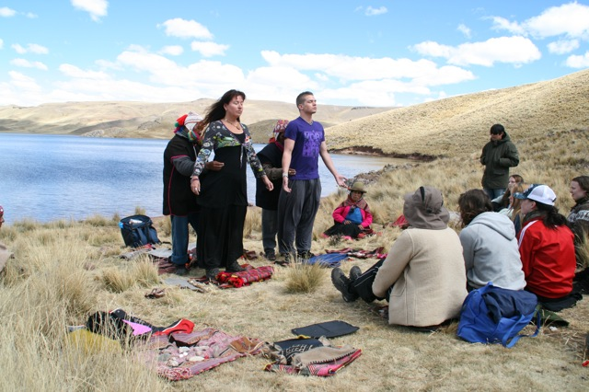

A healing journey

Walking the Path of Love and Balance

For rebalancing the masculine and feminine within and for our mother earth A Journey of Apprenticeship in the Sacred Places of Peru

With Karen, Victor, Dennis and the Q’ ero Paqo’s

The Nusta Karpay is a journey of awakening the Divine Feminine through a series of seven karpays, other names are: rites / transmissions / initiations. They are offered by the Qero Paqos at a variety of sacred sites in Peru. To the people of the Andes, the Nustas are the princesses, goddesses or priestesses, who reside at specific natural areas and sacred sites within the region of the Andes. As we walk together through the beautiful landscape of Peru, these lovely and powerful feminine energies will guide you and assist you on your journey, gifting you with their healing infusions and supporting you in cultivating and deepening your connection to these energies that are swirling within you and within the cosmos. So that there can be a new balance in the masculine and feminine in us all and for our mother earth: Pacha Mama. We feel so delighted and blessed to do this holy work together! Good to know is that if it’s necessary sometimes we translate in Dutch or Swedish, but most of the time the journey will be in the English language.

Special on this journey is: you create your own Nusta Mesa by collecting your khuya’s / medicinestones at the sacred places where you receive the initiations from the Paqo’s. And you can buy most of the items for the Nusta Kit in Peru yourself. You use these special sacred items for your Blossoming back home. In this way you can integrate all these beautiful Nusta energies in a deeper level in yourself and in the world.

You are most welcome to joyn us!

Munay Sonqoy
Karen, Victor, Dennis, the Q’ ero Paqo’s

